Create email newsletter design using MailChimp or canva tool. 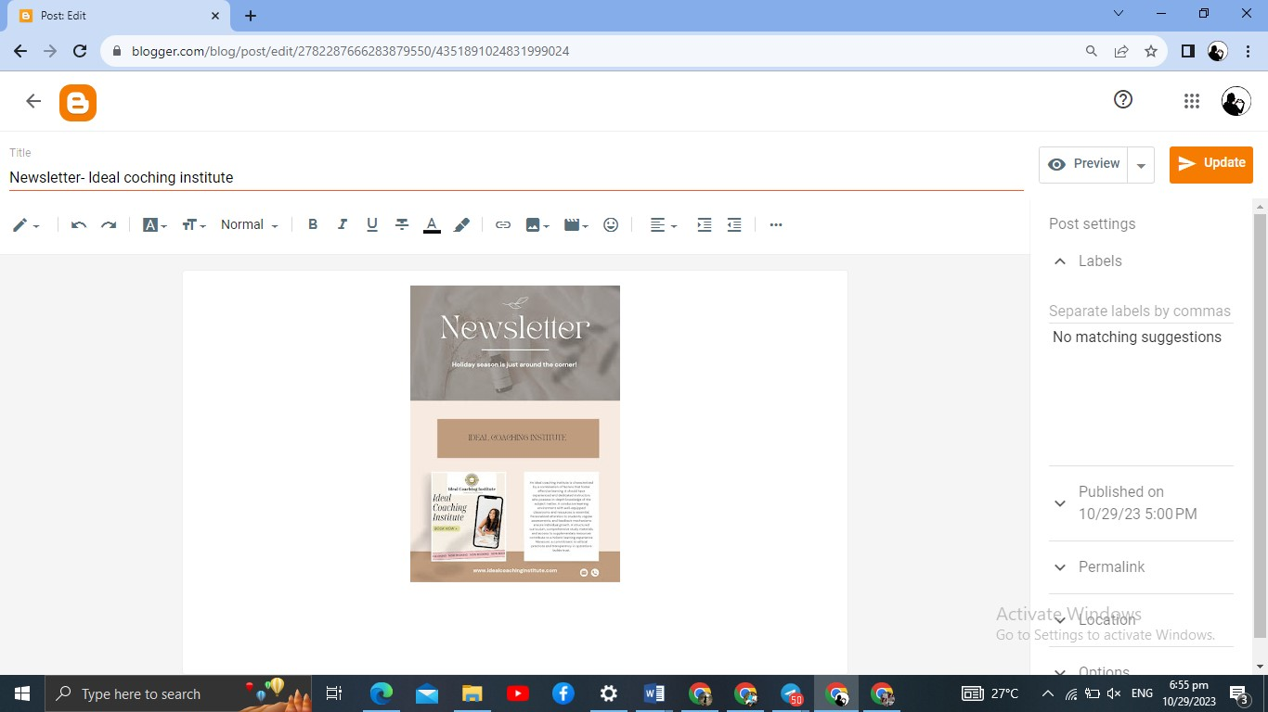

|  |  |
| --- | --- |
| NAME | SUGANYA S |
| NM ID | 25EB862AA19601B911A45D45BC50748B |
| ASSIGNMENT 4 | Newsletter design https://suganyas7190483.blogspot.com/2023/10/newsletterldeal-coching-institute.html |